Title of Abstract in APMSR2019 (The title size is 14pt bold.)
Jin-Han Jeon^{1,2}, Il-Kwon Oh^{1,*} (The authors’ name should be written the full name. Mark the speaker with underline)
¹Department, Affiliation, City, Country, ²Department, Affiliation, City, Country
*Corresponding author (Tel: +82-42-350-1520; E-mail: Second@abc.edu.hk)
Abstract
A short summary (max 300 words) of the work should be written here. The submitted abstract will be used for reviewing the presentation quality and relevance in reverence to the APMSR2019 tradition. All abstracts have to be written strictly according to the instructions set here. The length for the abstract is limited to 1 page, including a representative picture that may be produced in color, but can be also reproduced clearly in black and white. The font is Times New Roman in abstract. The authors’ name should be written the full name (first and last name order, size is same). The prescribed tool is: Microsoft Word in preparation and submission, PDF version is also required in submission.
Keywords: ((Five maximum))

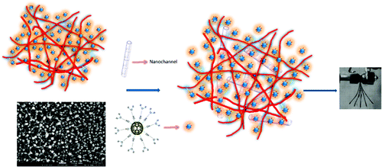
Fig. 1. Write the figure caption here.

